Assignment # 5 Name: Tarun Banda

Program 1: Count.java

**Screenshot (Sample Run) :**  GIVE IMAGE screen shot of the program running

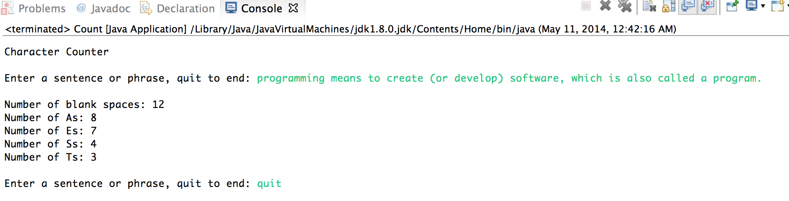

Program 2: PayCheck.java

**Screenshot (Sample Run):** GIVE IMAGE screen shot of the program running

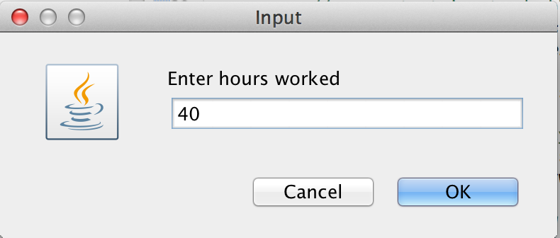

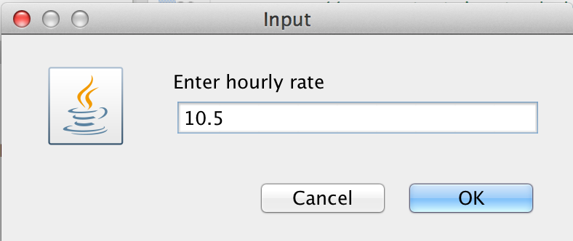

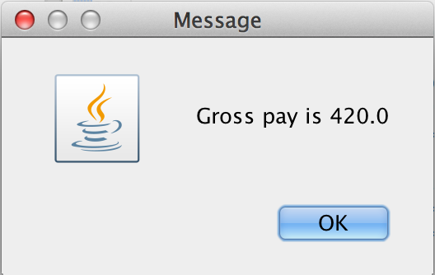

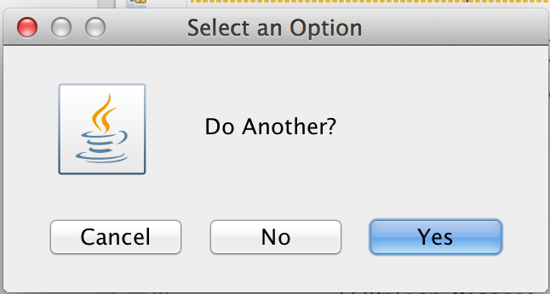

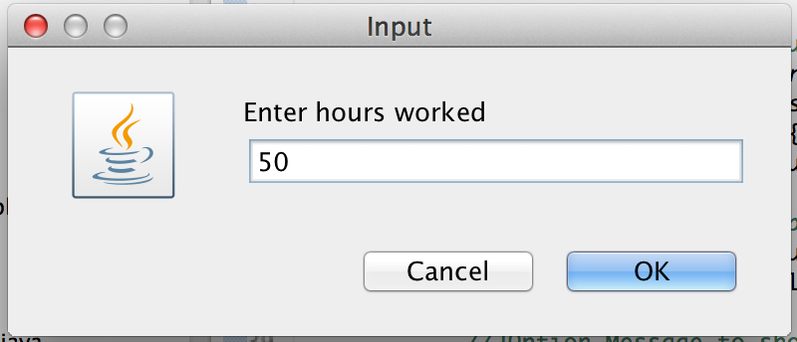

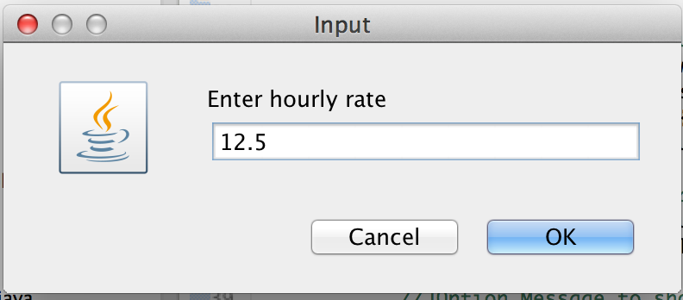

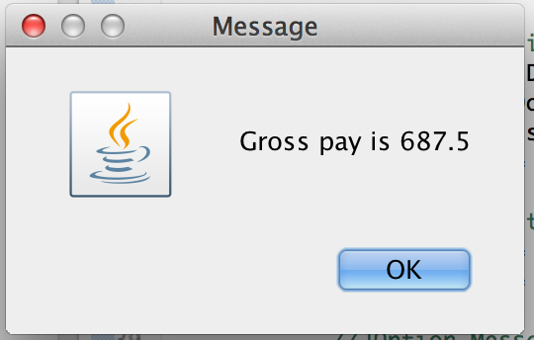

Program 3: MaxValue.java

**Screenshot (Sample Run):** GIVE IMAGE screen shot of the program running

